Last Updated

23/09/2021

Software Version

0.3.9.3

Clyde River Application

User Manual

Table of Contents

1 Getting Started 2

1.1 Introduction 2

1.2 Authors 2

1.3 Installation & Configuration 3

1.4 Features & Capabilities 3

2 Making The Most Out Of The Application 4

2.1 Navigating The Application 4

2.2 Viewing All Sensors 6

2.3 Viewing A Single Sensor 6

2.4 Changing Between Single Sensors 7

2.5 Setting up/Changing Between A Favourite Sensor 9

2.6 Viewing Salinity Data 11

2.7 Viewing Temperature Data 12

2.8 Viewing Rainfall Data 13

2.9 Changing Time/Date Range For Rainfall Data 14

3 Troubleshooting 15

3.1 Insert Title 15

3.2 Insert Title 15

3.3 Insert Title 15

# Getting Started

Table of Contents

1. Getting Started2
2. Introduction2
3. Authors2
4. Installation & Configuration3
5. Features & Capabilities3

# IntroductionGetting Started

Table of Contents

1. Getting Started2

Introduction2

Authors2

Installation & Configuration3

Type chapter title (level 3)6

# Introduction

# AuthorsIntroductionGetting Started

Table of Contents

1. Getting Started2

Introduction2

Authors2

Installation & Configuration3

Type chapter title (level 3)6

# IntroductionGetting Started

Table of Contents

1. Getting Started2

Introduction2

Authors2

Installation & Configuration3

Type chapter title (level 3)6

# Introduction

# AuthorsIntroduction

# Authors

# Installation & ConfigurationAuthorsIntroduction

# AuthorsIntroductionGetting Started

Table of Contents

1. Getting Started2
2. Introduction2
3. Authors2
4. Installation & Configuration3
5. Features & Capabilities6

# IntroductionGetting Started

Table of Contents

1. Getting Started2

Introduction2

Authors2

Installation & Configuration3

Type chapter title (level 3)6

# Introduction

# AuthorsIntroductionGetting Started

Table of Contents

1. Getting Started2

Introduction2

Authors2

Installation & Configuration3

Type chapter title (level 3)6

# IntroductionGetting Started

Table of Contents

1. Getting Started2

Introduction2

Authors2

Installation & Configuration3

Type chapter title (level 3)6

# Introduction

# AuthorsIntroduction

# Authors

# Installation & ConfigurationAuthorsIntroduction

# AuthorsIntroduction

# Authors

# Installation & ConfigurationAuthors

# Installation & Configuration

# Installation & ConfigurationAuthors

# Installation & ConfigurationAuthorsIntroduction

# AuthorsIntroduction

# Authors

# Installation & ConfigurationAuthorsIntroduction

# AuthorsIntroduction

Welcome to the Clyde River Desktop Application. This application will provide you with the capability to view Salinity, Temperature and Rainfall data from sensors placed on the Clyde River. As well as a number of other handy features.

This application has been designed in the Java language and therefore should be highly compatible with whatever system you are running.

This user manual has been provided for your convenience and should be able to sufficiently guide you through the necessary steps to explore the features of this application and assist you with whatever steps you may wish to take.



# Authors

# Installation & ConfigurationAuthors

# Installation & Configuration

# Installation & ConfigurationAuthors

# Installation & ConfigurationAuthors

# Installation & Configuration

# Installation & Configuration

# Installation & Configuration

1. Installation & Configuration

# Authors

# Installation & ConfigurationAuthors

# Installation & Configuration

# Installation & ConfigurationAuthors

# Installation & ConfigurationAuthors

This application and accompanying user manual has been developed and designed by Naomi Thompson.



# 1.3 Installation & Configuration

# Installation & Configuration

# Installation & Configuration

# Installation & Configuration

# Installation & Configuration

# Installation & Configuration

# Installation & Configuration

# Installation & Configuration

***[This section still needs to be completed]***

# Features & Capabilities

# Features & Capabilities

# Features & Capabilities

# Features & Capabilities

# Features & Capabilities

# Features & Capabilities

# Features & Capabilities

# Features & Capabilities

This software has the following features & capabilities:

* Ability To Check Current Salinity Levels for a Single Sensor
* Ability To Check Current Salinity Levels for All Sensors
* Ability To Check Current Temperature Levels for a Single Sensor
* Ability To Check Current Temperature Levels for All Sensors
* Ability To Check Current Rainfall Levels for a Single Sensor
* Ability To Check Current Rainfall Levels for All Sensors
* Ability To Set A Favourite Sensor
* Ability To Change A Favourite Sensor
* Ability To View A Summary of All Sensors At Once *
* Ability To See Harvest Location Status
* Rainfall Data Viewable To A custom Time range
* Provides A Convenient Landing Dashboard that shows a summary of the favourited location
* Provides All Data In Graphs
* Able To load custom data from a file *

# Making The Most Of The Application

Table of Contents

1. Making The Most Of The Application4

2.1 Navigating The Application4

2.2 Viewing All Sensors6

2.3 Viewing A Single Sensor6

2.4 Changing Between Single Sensors7

2.5 Setting Up/Changing Between A Favourite Sensor9

2.6 Viewing Salinity Data11

2.7 Viewing Temperature Data12

2.8 Viewing Rainfall Data13

2.9 Changing the Time/Date Range For Rainfall Data14

# Making The Most Of The Application

Table of Contents

1. Making The Most Of The Application4

2.1 Navigating The Application4

2.2 Viewing All Sensors6

2.3 Viewing A Single Sensor6

2.4 Changing Between Single Sensors7

2.5 Setting Up/Changing Between A Favourite Sensor9

2.6 Viewing Salinity Data11

2.7 Viewing Temperature Data12

2.8 Viewing Rainfall Data13

2.9 Changing the Tim/Date Range For Rainfall Data14

# 2.1 Navigating The Application

# Features & Capabilities

# Features & Capabilities

# Features & Capabilities

# 2.1 Navigating The Application

# Features & Capabilities

# Features & Capabilities

# Features & Capabilities

3

2

1

10

7

6

5

9

8

4

Before you get started with your brand new application, you should become familiar with it’s layout.

Above you will notice we have an annotated image to help you out.

Next we will talk about each of the identified parts to help you understand the application better.

The Menu:

1. This Is The **Home** option. It will bring you back to this dashboard at any time.
2. This is the **Sensors** option. Selecting this will bring you to a screen with the sensors sorted into lists for easy access to individual sensors.
3. This is the **Data** option. Under here you can find access to the different data types.
4. This is the **Exit** option. It will close the application at any time for you.
5. This is the **All Salinity Levels** option. It will allow you to access a summary of the salinity levels across all sensors.
6. This is the **All Temperature Levels** option. It will allow you to access a summary of the temperature levels across all sensors.
7. This is the **All Rainfall Levels** option. It will allow you to access a summary of the Rainfall levels across all sensors.

The Content:

1. This is the window **Title**. It will tell you where you are within the application
2. This is your **Favourite Sensor**.
3. These are **Graphs**. They are directly linked to your *Favourite Sensor*. They will provide you with a quick summary of the sensor.

# 2.2 Viewing All Sensors

# Features & Capabilities

# Features & Capabilities

# Features & Capabilities

# 2.2 Viewing All Sensors

# Features & Capabilities

# Features & Capabilities

# Features & Capabilities

To view a list of all sensors that are currently available including all available harvest areas:

From The **Dashboard**

Go To The **Menu**

Select the *Sensors* option.

# 2.3 Viewing A Single Sensor

# Features & Capabilities

# Features & Capabilities

# Features & Capabilities

# 2.3 Viewing A Single Sensor

# Features & Capabilities

# Features & Capabilities

# Features & Capabilities

To View a Single Sensor, follow the instructions for ***Viewing All Sensors***

Then proceed with the following instructions.

Then Simply locate the sensor you want to view.

And click on it.

Sensors are organized into 2 lists, **Harvest Area** sensors and **Non-Harvest Area** sensors.

Each List Is then organized geographically beginning with Wray Street at the mouth of the river and working progressively further down the river.

# 2.4 Changing Between Single Sensors

# Features & Capabilities

# Features & Capabilities

# Features & Capabilities

# 2.4 Changing Between Single Sensors

# Features & Capabilities

# Features & Capabilities

# Features & Capabilities

To change between individual sensors, begin by following the instructions for ***Viewing All Sensors***. Then proceed with the instructions for ***Viewing A Single Sensor***.

Then proceed with the following instructions.

At this point you should be looking at the information for a single sensor.

If you are not, then please start the process again and follow each step carefully.

If you look to the left of your window, you should notice a list on the left hand side. This list is organized geographically.

Look through the list to find the corresponding sensor you would like to view next and click on it.

You should now be viewing a different sensor.

You can confirm this by checking the window title has updated. The chart should also have updated.

# 2.5 Setting Up/Changing A Favourite Sensor

# Features & Capabilities

# Features & Capabilities

# Features & Capabilities

# 2.5 Setting Up/Changing A Favourite Sensor

# Features & Capabilities

# Features & Capabilities

# Features & Capabilities

In Order to setup or change a favourite sensor you need to first determine into which group you fall.

Do you need to setup a favourite sensor for the first time? Or are you changing your favourite sensor?

Which group you fall into determines how far you go through the instructions.

**Set Up A Favourite Sensor**

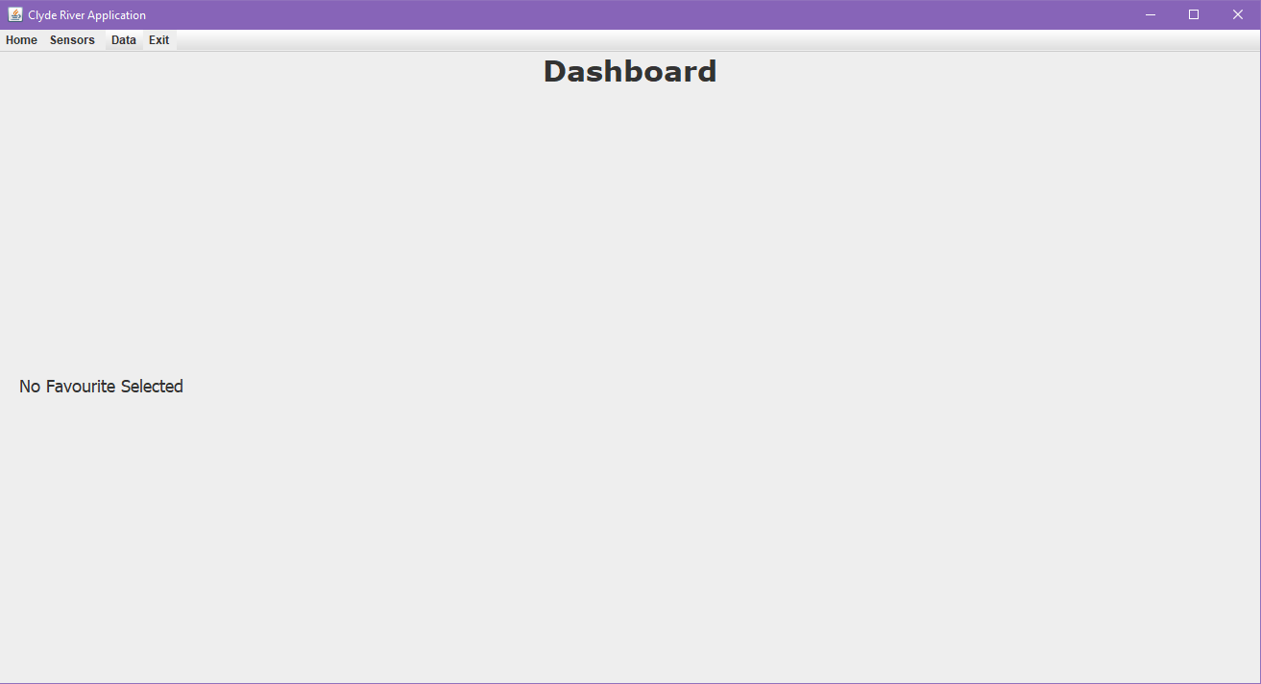

From the Home Screen

Click On Either the *Sensors* items in the menu or the message prompting you to create a new favourite.

**Change An Existing Favourite Sensor**

Click on *Sensors* on the menu bar.

At this point you should be looking at a list of all available sensors.

Locate and Select the sensor you want to make a favourite.

should now be looking at that specific sensor.

Select the star (Or **checkbox** in this case) to the left of the **title**.

Congratulations if you had no favourite before, you have now setup a new favourite sensor.

If you have an existing favourite you will be prompted to check whether you intended to replace it. Select **Yes**.

# 2.6 Viewing Salinity Data

# Features & Capabilities

# Features & Capabilities

# Features & Capabilities

# 2.6 Viewing Salinity Data

# Features & Capabilities

# Features & Capabilities

# Features & Capabilities

To view salinity data, begin by going to the **Menu**.

Click on the *Data* option in the menu.

From there select the *All Salinity Levels* option to view a quick summary of the salinity levels across all available sensors.

To view a single sensor instead, simply click on it.

# 2.7 Viewing Temperature Data

# Features & Capabilities

# Features & Capabilities

# Features & Capabilities

# 2.7 Viewing Temperature Data

# Features & Capabilities

# Features & Capabilities

# Features & Capabilities

To view salinity data, begin by going to the **Menu**.

Click on the *Data* option in the menu.

From there select the *All Temperature Levels* option to view a quick summary of the salinity levels across all available sensors.

To view a single sensor instead, simply click on it.

# 2.8 Viewing Rainfall Data

# Features & Capabilities

# Features & Capabilities

# Features & Capabilities

# 2.8 Viewing Rainfall Data

# Features & Capabilities

# Features & Capabilities

# Features & Capabilities

To view salinity data, begin by going to the **Menu**.

Click on the *Data* option in the menu.

From there select the *All Rainfall Levels* option to view a quick summary of the salinity levels across all available sensors.

To view a single sensor instead, simply click on it.

# 2.9 Changing The Time/Date Range For Rainfall Data

# Features & Capabilities

# Features & Capabilities

# Features & Capabilities

[insert annotated screenshots]

To see a custom range for the rainfall levels of a single sensor, begin by following the instructions for ***Viewing Rainfall Data***.

You should now be looking at a single sensor showing current rainfall data.

If you look towards the bottom of the window, just below the graph, you should notice 2 icons that look a bit like a [calendar/clock/date thingy].

These are the date fields that allow you to set a custom time range. The one to the left is the time you want to begin from, the one to the right is where you want to end.

Simply pick the corresponding dates you need and the graph should automatically update to show the data corresponding to the new time range.

1. Troubleshooting

Table of Contents

1. Troubleshooting 15
   1. Application Does Not Start 15
   2. Chart Does Not Display Data 15
   3. Chart Does Not Display Up To Date Data 15
   4. Favourite Location Is Not Set 16
   5. Favourite Location Is Not Showing 16
   6. Insert Title 16

# 3.1 Application Does Not Start

# Features & Capabilities

# Features & Capabilities

# Features & Capabilities

If the application does or will not start, the first thing you should check is that you have Java installed.

If you aren’t sure, then follow the following instructions for your operating system.

**Windows**

**[INSERT SCREENSHOT]**

Go to the start menu

Begin typing *command prompt*

Alternatively you can locate the *command prompt* manually if you know how to.

Once you have located the *command prompt*, make sure you open it.

You should now see a window like this:

[INSERT SCREENSHOT]

Next you want to run type in and run the following command.

So begin by typing in “java -version” (without the quotes).

Then press enter.

This command will return the current version of any java installations that currently exist on your computer.

Such as this:

[INSERT SCREENSHOT]

If you however get a different result more like this:

[INSERT SCREENSHOT]

Then you need to install Java. In which case you should go to the following website and download and install Java because the application requires Java in order to run.

Java Download: <https://www.java.com/en/download/>

**Mac**

[INSERT SCREENSHOT]

From the desktop, open the *Applications* folder

Scroll down and find the *Utilities* folder.

Open it and locate *Terminal*.

[INSERT SCREENSHOT]

You should now be looking at the above window.

From this point you need to type in the following command.

“java -version” (Without the quotes)

[INSERT SCREENSHOT]

You should get a message similar to this.

If you get anything else then you need to download java.

Java Download: <https://www.java.com/en/download/>

**Linux**

Because Linux comes in many flavours, these instructions may not be a perfect fit for your operating system. That said, they should be similar enough that you can follow along, whatever your preferred version of Linux is.

# 3.2 Chart Does Not Display Data

# Features & Capabilities

# Features & Capabilities

# Features & Capabilities

# 3.3 Chart Does Not Display Up To Date Data

# Features & Capabilities

# Features & Capabilities

# Features & Capabilities

# 3.4 Favourite Location Is Not Set

# Features & Capabilities

# Features & Capabilities

# Features & Capabilities

# 3.5 Favourite Location Is Not Showing

# Features & Capabilities

# Features & Capabilities

# Features & Capabilities

# 3.6 Insert Title

# Features & Capabilities

# Features & Capabilities

# Features & Capabilities